Winspect

Network traffic monitoring system
using Windows Filtering Platform
(Driver and Control Application)

Software Requirements Specification

DRAFT

Table of contents

- Summary
- Features description
- System architecture description
3.1 Driver
3.2 Control Application
- Tools used
- Project roadmap
- Links

1. Summary
The goal of the project is to build simple traffic monitoring system using Windows Filtering Platform. This project is educational one and primarily intended to study WFP mechanisms. Features list mostly has been taken from NetLimiter 3 Monitor Application (Locktime Software s.r.o.) description.

2. Features description
Set of features to be implemented mostly has been taken from NetLimiter 3 Monitor Application.
Features marked with green are urgent for the project and should be implemented anyway. Features marked with yellow are optional.
Feature | Description
Connections monitoring. | Monitoring and displaying to user all connections opened by each process.
Connections blocking. | Availability to allow or disallow a process to open a connection.
Address-based packet filtering. | Basic “allow/drop” packet filtering function using source and destination addresses from packet header.
Displaying connections. | Showing connections list for selected processes to user.
Displaying packet contents. | Displaying header and contents of packets using filtering rules.
Packets header modification. | Modification of source and destination addresses in packet's header.
Packets data modification. | Modification of payload of packet's body.

Contents of this section may change during project's lifecycle.

3. System architecture description
Traffic monitoring application consists of two modules: kernel-space module (driver) and user-space control application.
The driver should provide filtering and rule-based tasks.
The control application should provide dispatching of user's commands to the driver (such as new filtering rules) and receive feedback from driver.

3.1 Driver
The driver is a callout driver connected to kernel-mode filter engine through Microsoft Callout API. The driver uses predefined ALE layers.

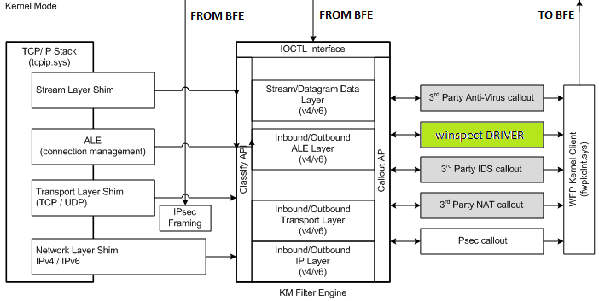
Fig 3.1 – Kernel-mode part of the application

3.2 Control Application
The control application interacts with user and controls the driver. List of possible functions includes:
- Receiving driver's status;
- Sending control commands such as switch on/off filtering, get ports list etc;
- Creating, loading, saving and sending to the driver new filtering rules;
- Interpreting connection and packet information received from driver;
- Advanced rule engine (optional, using scripts);
- Receiving and processing commands from user.
The control application resides in user space and interacts with the driver through BFE (Base Filter Engine).

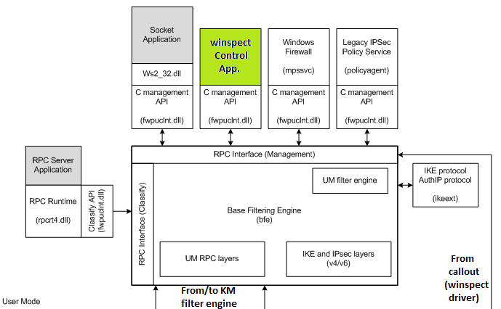
Fig 3.2 – Control application (user-mode part)

4. Tools used
1. Compiler kit and IDE: Microsoft Visual C++, Microsoft Visual Studio 2010 Express;
2. Driver Framework: Windows Driver Framework 7.1.0 (7600).

5. Project Roadmap
This section hasn't been written yet.

6. Links
1. Project's homepage: https://code.google.com/p/winspect/
2. SVN for project members:
svn checkout https://winspect.googlecode.com/svn/trunk/ winspect
3. SVN for anonymous access:
svn checkout http://winspect.googlecode.com/svn/trunk/ winspect-read-only

